2 ways to do H3 - Cyclical

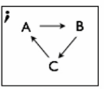

1. Adopt the H2 case

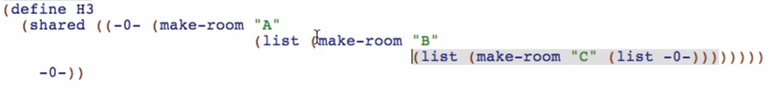

1. Preferable as the graph structure gets larger

* Giving labels to all of the rooms
* Different naming convention

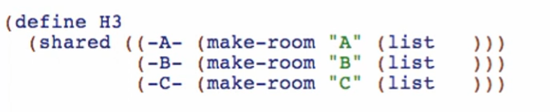

Fill it up

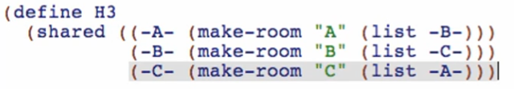

Produce the root room

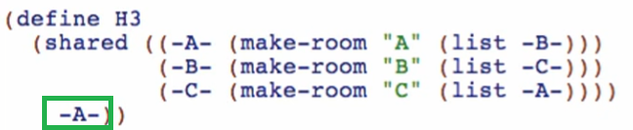

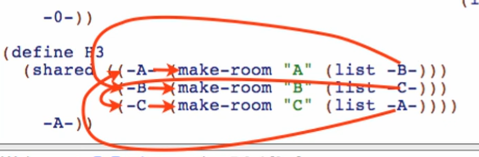

Running it, racket produces this:



It doesn’t remember our labels per room. So, to check this, we can use selectors

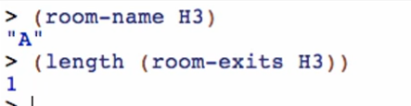



Doing the H4 using the preferable way

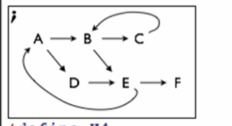

Provide labels for each node:

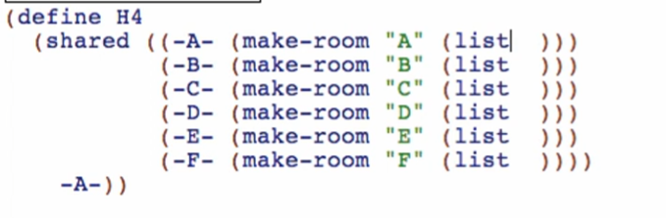

Fill up the exits using the labels

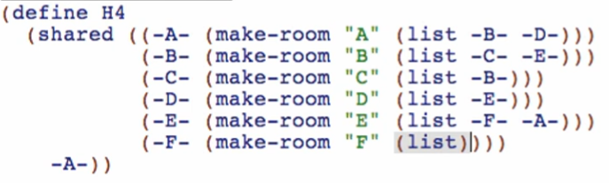

Run and check if well-formed

Racket will show it like this:

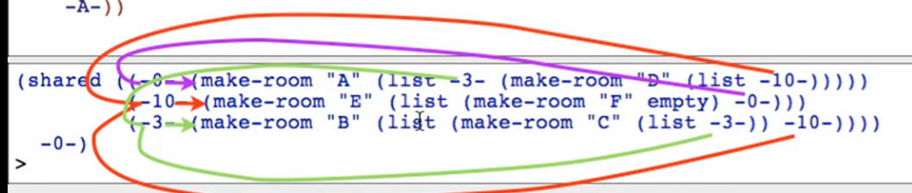

But it’s just the same!

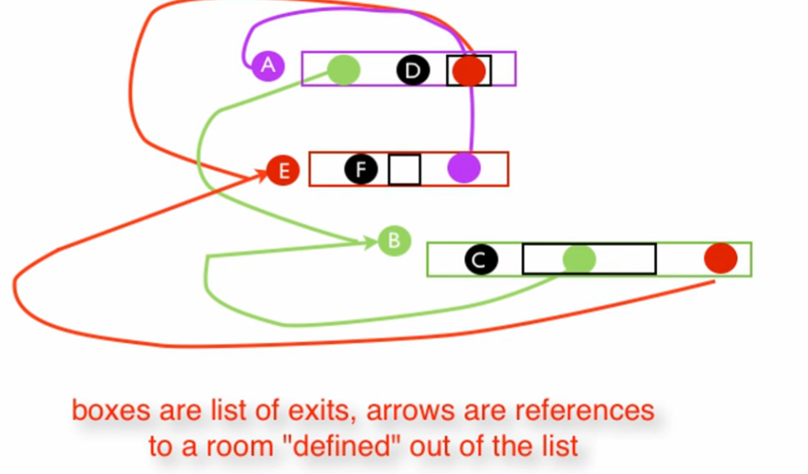

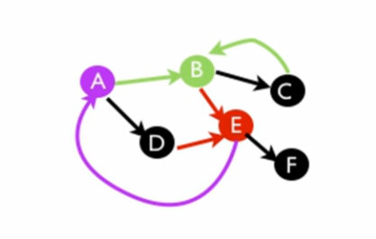

Sample Questions:

